­

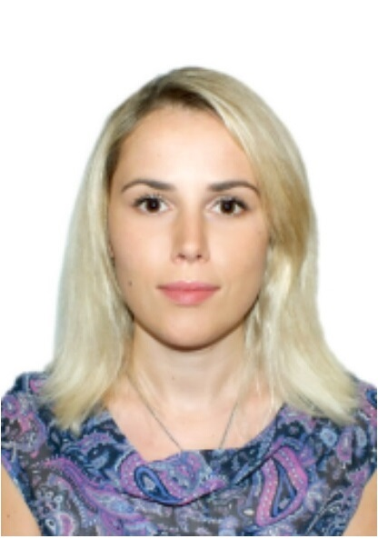

Administration and Management Professional with 10+ Years of Experience in UAE, Turkey and Ukraine

**Tetiana Khomych**

**Personal statement**

A meticulous, efficient and organized administrator and management professional with over 15 years’ experience and a record of working to very high standards. I have expertise for overall direction, coordination, implementation, execution, control and completion of specific projects ensuring consistency with company strategy, commitments and goals. I possess astute business understanding and experience in contributing to deliver improvements in processes, productivity, and costs in export sales and business development. I have a vibrant and logical mind with a practical approach to problem solving and a determination to accomplish tasks.

**CONTACT**



owcareers@gmail.com

­

Jumera Village Circle - UAE



+12345566777

**WORK EXPERIENCE**

**Objectives**

Seeking middle to senior level position in Administration and Managment department, demanding high standards of quality, precision and providing opportunities for professional growth and development.

|  |
| --- |
| **Sales Agent** Feb 2014 - Date  (Direct Reservations, Sales and Promotion Department) Atlantis, The Palm - UAE |

|  |  |
| --- | --- |
| **Account Receivable**  Address Down Town Hotel - UAE | Feb 2013 - Jan 2014 |
|  |  |

|  |  |
| --- | --- |
| **Cashier**  Emaar Group Hotel - UAE | Dec 2011 - Jan 2013 |

|  |  |
| --- | --- |
| **Guest - Relation**  Lindita Hotel Club - Turkey | Mar 2009 - Nov 2010 |

|  |  |
| --- | --- |
| **ZAO ZAZ (Car Plant) - Ukraine** |  |

Production Manager - Full Rotation Sep 2006 - Feb 2009

Junior Project Manager Oct 2005 - Aug 2007

Dealer Liaison Coordinator Jan 2005 - Sep 2005

Human Resources Officer Feb 2004 - Jan 2005

­

**Key Performances**

**Project managment in manufacturing sector. Controlling & management of production department and Administration in hospitality sector.**

**Education**

Managment Economics (Industrial Managment) 2006

State Engineering Acedmy

**Certifications**

Training Accounts Receivable Certificate 2013

Eton Insitute Engli Hospitality Certificate 2012

Basic Food Hygiene Certificate 2012

**Professional Highlights**

**SKILLS**

Administration

Hotel management

Customer relation

Budgeting

Product sales

Innovative thinking

Accounts receivable

Cash management

Hotel operations

Food service

Maintenance and Cleaning

Business acumen

IT skills

Team building & management

Training and Developments

* Managing and administering hotel activities;
* Introducing new products, reviewing sales performance, aiming to meet or exceeding targets;
* Making accurate, rapid cost calculations and providing customers with quotations;
* Confirming reservations according to rates that are currently in effect and arranges the billing according to hotel procedures;
* Handling group tours / conventions from the initial blockage to the rooming lists;
* Recording all reservations neatly and accurately on prescribed forms;
* Handling all advance deposits received by crediting the amounts into the correct guest’s folios and issuing receipts to the senders;
* Checking incoming letters, telexes and faxes than distributing to whom it may concerned within the reservation department;
* Updating computer immediately and accurately if there’s any changes & sends out confirmation slip promptly if requested;
* Handling any request for amenities or transportation promptly and accurately;
* Updating guest history records, travel agency/company records and account receivable records on a regular basis;
* Dealing with cash-flow and communicationg with customers;
* Completing the night time close, audits and working with all functions to work as a team for the business;
* Facilitating all kind of payments;
* Dealing with all employee matters and compensation;
* Producing and carrying out work studies and building relationships with employees over all matters;
* Building relationships with dealers over all delivery matters and ensuring deliveries met specification and working with quality teams;
* Developing full scale projects plans and managing budgets; and
* Quality assurance, constantly monitoring and reporting on progress of the project to all stakeholders.

­